1. **Characteristic of pH sensor**
2. *Investigate how EMF type pH sensors work briefly.*

Potentiometric pH meters measure the voltage between two electrodes (reference electrode and a glass electrode). The glass electrode has a glass bulb specifically designed to be selective to hydrogen-ion concentration. Hydrogen ions in the test solution exchange for other positively charged ions on the glass bulb, creating an electrochemical potential across the bulb. (Electromotive Force, EMF, is created.)

The magnitude of this potential is related to the pH according to the Nernst equation. (if reference electrode is standard hydrogen electrode, E = -0..059 log[H])

1. *What is the baseline or initial values in sensors?*

The initial value or baseline of sensor is incorrect, for the electrode may become depleted, diluted, or even poisoned over time. Thus, calibration of a sensor is mandatory. Initial calibration of a new pH sensor is done in liquid buffer solution, for buffers provide a stable pH value that the sensor can be checked against.

1. *What is the sensitivity in sensors?*

In sensors, sensitivity is defined as the ratio between the output signal and measured property. For pH sensors, for example, the sensitivity is a constant with the unit [V/pH] (or [mV/pH]. The sensitivity is the slope of the transfer function.

1. **BJT amplifier and CMOS amplifier**

*What is difference between BJT and CMOS amplifier?*

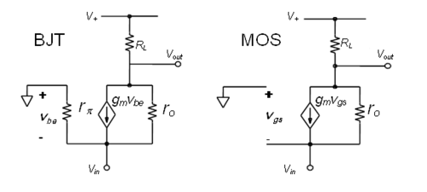

BJT amplifier, or bipolar junction transistor amplifier is essentially a current dependent amplifier, while CMOS (Complementary MOS) amplifier is a voltage dependent amplifier. Current through BJT is dependent on the current at the base, while MOSFET depends on the voltage of the gate electrode.

BJTs are preferred for low current application, while CMOSs are for high power functions.

1. **Inverting amplifier and non-inverting amplifier**

*Explain operations of the inverting amplifier and non-inverting amplifier.*

*What is difference of these amplifiers?*

Inverting amplifier has negative sign gain, while non-inverting amplifier has positive sign gain. In other words, Non-inverting is those whose input and output are in phase, and inverting is out of phase.

For OP-amp, inverting amplifier and non-inverting amplifiers can be accomplished by following circuit.

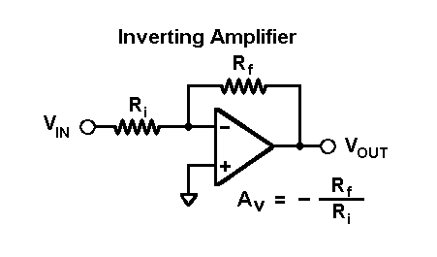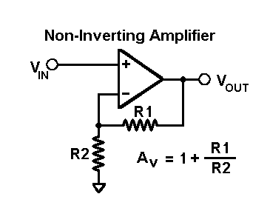

For CMOS amplifier, inverting amplifier is common source, while non-inverting is common gate and common drain.

